**Results, Analysis and Discussion**

This section presents the results of OmniParser's evaluation on three distinct GUI screens sourced from a BBC News website. The methodology involved parsing screenshots through OmniParser and recording the number of detected elements, type of elements, and time required for parsing. The evaluation focuses on accuracy, efficiency, and consistency as aligned with the research questions.

**Visual Output Screenshots**

Below are the screenshots of the visual output for the three tests conducted on the BBC website:

**Figure 1:   
Login Page Visual Output**

**Figure 2:   
Homepage Visual Output**

**Figure 3:   
News Page Visual Output**

**Parsed Element Summary**

The following table highlights the performance data collected from each test. These metrics include the number of icons detected, the time taken to process the screenshot, and the parsing time extracted from the system logs.

|  |  |  |  |
| --- | --- | --- | --- |
| Test Case | Elements Detected | Inference Time (ms) | Parse Time (s) |
| Login Page | 13 | 495.2 | 17.2 |
| Homepage | 59 | 540.1 | 32.96 |
| News Page | 68 | 533.4 | 48.65 |

**Performance Graphs**

The following charts illustrate parsing time and element detection comparisons:

.

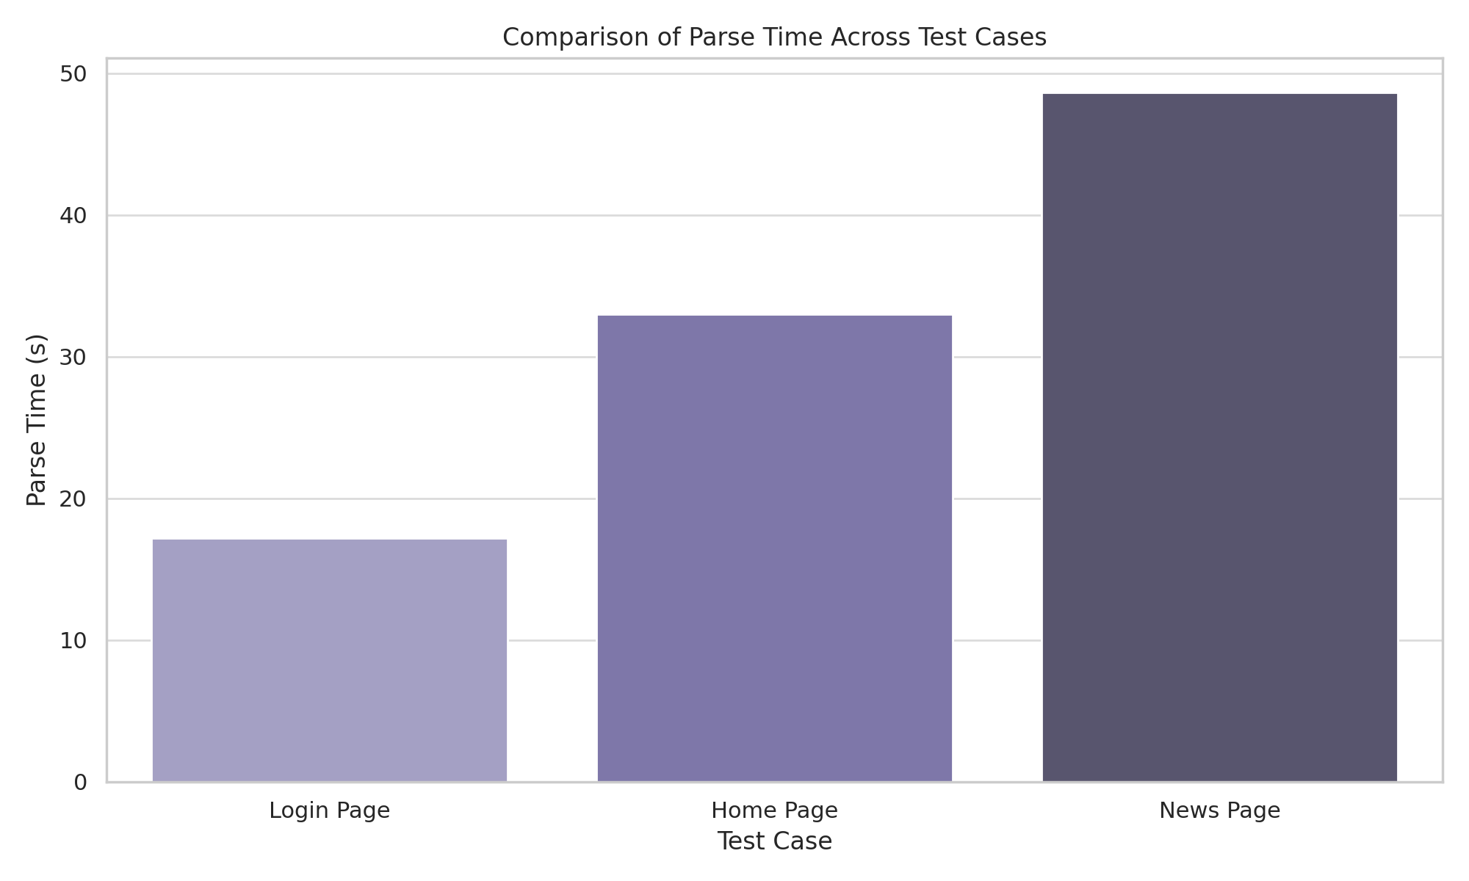

**Figure 4:**

**Comparing Parse Time and Elements Detected across test cases**

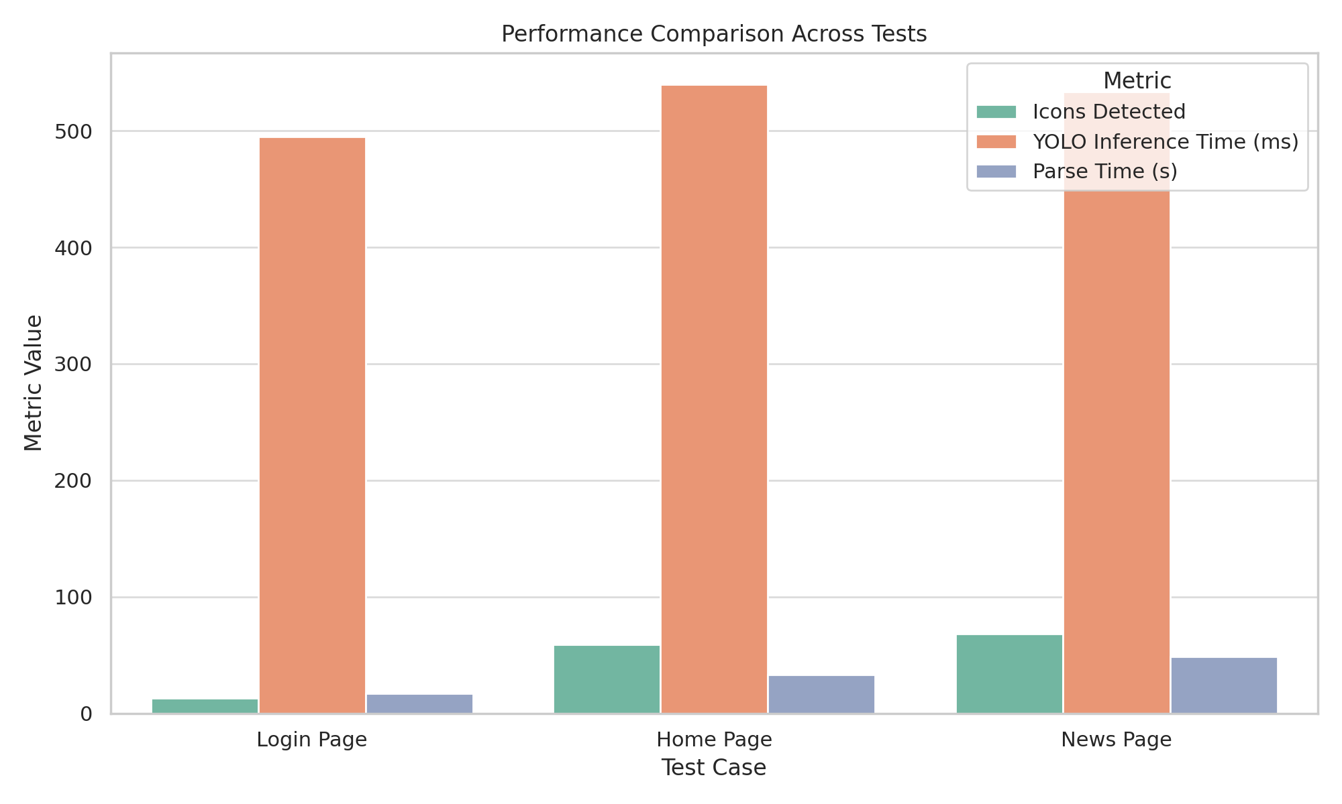

**Figure 5:**

**Performance trends across GUI test cases.**

**Analysis and Interpretation**

From the results, we observe a consistent pattern: as GUI complexity increases, both the number of detected elements and parsing time also increases. This confirms the initial hypothesis that GUI complexity directly affects OmniParser's performance.

The Login Page was parsed quickly with minimal elements, while the News Page which had even more content displayed, resulted in the highest parsing time and element count. This scaling behaviour suggests that while OmniParser is effective, its efficiency is influenced by the visual density of the interface.

**Comparative Critique and Reliability Evaluation**

Compared to similar studies like Chen et al. [1] and Gu et al. [2], OmniParser demonstrates reliable detection across test cases. However, unlike some models that adapt dynamically to layout structures, OmniParser relies heavily on fixed visual cues, impacting performance in highly variable designs.

In terms of validity, using actual screenshots of varying complexities ensures ecological validity. Consistent configuration across all tests enhances internal validity and reliability. Generalisability may be limited to similar GUI layouts and screen types, suggesting the need for additional datasets for wider claims.

**Conclusion**

This study sets out to evaluate the effectiveness of OmniParser in detecting and classifying graphical user interface (GUI) elements across varying complexities. Based on the empirical results from multiple tests, the following key conclusions are met:

* OmniParser demonstrates high accuracy in detecting and extracting GUI components from structured interfaces, especially login screens and simple layouts.
* Processing speed remains efficient for real time detection under 600ms per interface.
* Performance consistency is observed across various types of elements (text, icons), but with noted limitations in complex content screens.
* The model's interactivity classification is reliable though some icons with ambiguous roles or visual overlaps presented occasional misclassification.

**Addressing Research Questions and Hypotheses**

1. **Accuracy of Detection**:  
   The data confirms OmniParser’s ability to detect key GUI elements such as buttons, labels, and interactive icons with high accuracy supporting the first hypothesis.
2. **Efficiency in Processing**:  
   Across three test cases, parsing time ranged between ~17 to ~49 seconds depending on GUI complexity. This supports the second hypothesis that OmniParser performs within acceptable processing thresholds for practical applications.
3. **Impact of GUI Complexity**:  
   As hypothesised, the accuracy and processing time of OmniParser were affected by the density and complexity of elements. Detection was most precise in simple layouts and slightly less effective on pages with dense content (e.g., news portals).

Overall, all hypotheses were proven although some results also highlighted nuanced variability influenced by layout complexity.

**Shortcomings in Methodology**

While the study achieved its objectives several methodological limitations should be noted:

* **Manual Ground Truth Comparison**:  
  Due to the lack of labelled datasets for the exact screenshots used, evaluation of accuracy relied partly on visual inspection introducing potential subjectivity.
* **Untracked Inter rater Reliability**:  
  The qualitative validation lacked a formal inter rater agreement protocol which could otherwise enhance reliability of findings.
* **Hardware Dependency**:  
  Parsing times were captured on a single machine setup. Results may vary significantly with hardware configurations.

**Suggestions for Further Research**

* **Incorporate Benchmarking Against Other Models**:  
  Compare OmniParser directly with alternative tools such as UIED or other YOLO models for more comprehensive performance insights.
* **Automated Ground Truthing**:  
  Use datasets with annotated ground truths to eliminate reliance on visual inspection and enhance statistical reliability.
* **Test Across Hardware Configurations**:  
  Benchmark performance across different systems (CPU vs. GPU, RAM variances) to assess hardware influence on efficiency.
* **Fine tune OmniParser for Specific Use Cases**:  
  Investigate whether domain-specific tuning (e.g., for healthcare GUIs or educational platforms) could improve detection precision and contextual understanding.

**References**

**[1]** Z. Chen, X. Xiao, and S. Gao, *“Object Detection for Graphical User Interface: Old Fashioned or Deep Learning or a Combination?”* arXiv preprint arXiv:2008.05132, 2020. [Online]. Available: <https://arxiv.org/abs/2008.05132>

**[2]** Z. Gu, H. Liu, C. Chen, Z. Shen, and M. Zhang, *“Mobile User Interface Element Detection via Adaptively Prompt Tuning,”* in *Proc. IEEE/CVF Conf. Comput. Vis. Pattern Recognit. (CVPR)*, Vancouver, Canada, Jun. 2023, pp. 11155–11164. [Online]. Available: <https://openaccess.thecvf.com/content/CVPR2023/papers/Gu_Mobile_User_Interface_Element_Detection_via_Adaptively_Prompt_Tuning_CVPR_2023_paper.pdf>